

Pain Assessment

Post-Assessment

Question Set 1

- Dull and aching commonly describe which type of pain:
  - visceral
  - somatic
  - neuropathic
  - nociceptive
  - all of the above
  - none of the above

- Shooting, burning and tingling describe which type of pain:
  - visceral
  - somatic
  - neuropathic
  - nociceptive
  - all of the above
  - none of the above

- Severe usually describes which type of pain?
  - visceral
  - somatic
  - neuropathic
  - nociceptive
  - all of the above
  - none of the above

- Pain reported as “cramping, all over my lower stomach” usually describes which type of pain?
  - visceral
  - somatic
  - neuropathic
  - nociceptive
  - all of the above
  - none of the above
Question Set 2

For each pain site shown on the body outline below:
a. Circle L if it is a localized site, P if it is a projected site, or R if it is a referred site?
b. Circle N if the pain is likely to be nociceptive or NP if it is likely to be neuropathic?

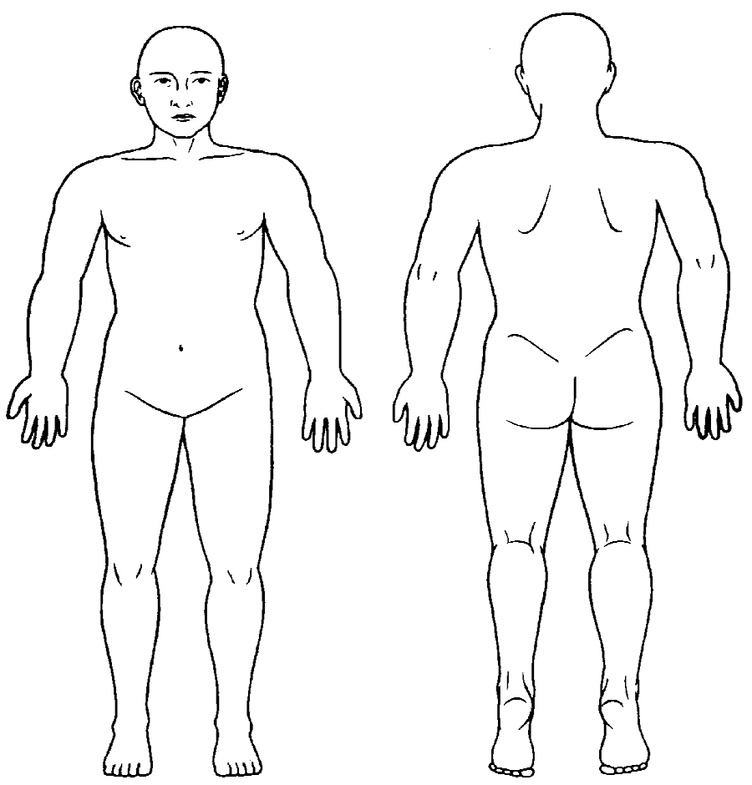
2.LRPNNP
1.LRPNNP
3.LRPNNP
4.LRPNNP
© 1989 D.J. Wilkie & K.A. Puntillo, figure only
Question Set 3
© 1989 D.J. Wilkie & K.A. Puntillo, figure only
For each pain site shown on the body outline below:
a. Circle L if it is a localized site, P if it is a projected site, or R if it is a referred site?
b. Circle N if the pain is likely to be nociceptive or NP if it is likely to be neuropathic?
4.LRPNNP
7.LRPNNP
1.LRPNNP
3.LRPNNP
6.LRPNNP
5.LRPNNP
2.LRPNNP
Question Set 4

For each pain site shown on the body outline below:
a. Circle L if it is a localized site, P if it is a projected site, or R if it is a referred site?
b. Circle N if the pain is likely to be nociceptive or NP if it is likely to be neuropathic?
1.LRPNNP
2.LRPNNP
4.LRPNNP
3.LRPNNP
© 1989 D.J. Wilkie & K.A. Puntillo, figure only
Question Set 5

For each pain site shown on the body outline below:
a. Circle L if it is a localized site, R if it is a referred site, or P if it is a projected site?
b. Circle N if the pain is likely to be nociceptive or NP if it is likely to be neuropathic?

3.LRPNNP
4.LRPNNP
2.LRPNNP

7.LRPNNP
8.LRPNNP
9.LRPNNP
6.LRPNNP
5.LRPNNP
1.LRPNNP
© 1989 D.J. Wilkie & K.A. Puntillo, figure only
Answers: Question Set 1

- Dull and aching commonly describe which type of pain:
Answer: d) nociceptive
- Shooting, burning and tingling describe which type of pain:
Answer: c) neuropathic

- Severe usually describes which type of pain?
Answer: e) all of the above
Any type of pain can be severe.

- Pain reported as “cramping, all over my lower stomach” usually describes which type of pain?
Answer: a) visceral
Answers: Question Set 2
For each pain site shown on the body outline below:
- Circle L if it is a localized site, P if it is a projected site, or R if it is a referred site?
- Circle N if the pain is likely to be nociceptive or NP if it is likely to be neuropathic?
- Answer: a. P; b NP
- Answer: a. P; b NP
- Answer: a. P; b NP
- Answer: a. P; b NP

Answers: Question Set 3
For each pain site shown on the body outline below:
- Circle L if it is a localized site, P if it is a projected site, or R if it is a referred site?
- Circle N if the pain is likely to be nociceptive or NP if it is likely to be neuropathic?
- Answer: a. P; b NP
- Answer: a. P; b NP
- Answer: a. P; b NP
- Answer: a. P; b NP
- Answer: a. P; b NP
- Answer: a. P; b NP
- Answer: a. P; b NP

Answers: Question Set 4
For each pain site shown on the body outline below:
a. Circle L if it is a localized site, P if it is a projected site, or R if it is a referred site?
- Circle N if the pain is likely to be nociceptive or NP if it is likely to be neuropathic?
- Answer: a. R; b N
- Answer: a. R; b N
- Answer: a. R; b N
- Answer: a. R; b N

Answers: Question Set 5

For each pain site shown on the body outline below:
a. Circle L if it is a localized site, P if it is a projected site, or R if it is a referred site?
- Circle N if the pain is likely to be nociceptive or NP if it is likely to be neuropathic?
- Answer: a. R; b N
- Answer: a. R; b N
- Answer: a. L; b N
- Answer: a. L; b N
- Answer: a. L; b N
- Answer: a. L; b N
- Answer: a. L; b N
- Answer: a. L; b N
- Answer: a. L; b N

